

Quinncia Mock Interview Instructions
One of Quinncia's key features is the mock interview using AI. These sessions provide useful feedback that will help you ace your interviews! Follow these steps to schedule your mock interview:
- Log in to Quinncia.io.
- If you're new to Quinncia, the system will prompt you to upload a PDF version of your resume. Refer to this article if you need help uploading your resume.
- Navigate to the Schedule Your Interview widget and click Schedule.
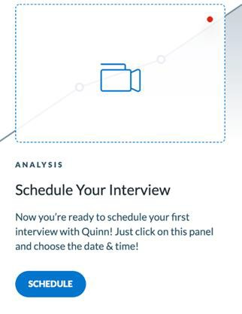
- Choose a date and time. You have to schedule at least 15 minutes in advance to ensure that you have time to set up and prepare.
- Receive an email in your inbox to confirm your interview time.
- Spend a few minutes practicing. Utilize the tips that we send in the email!

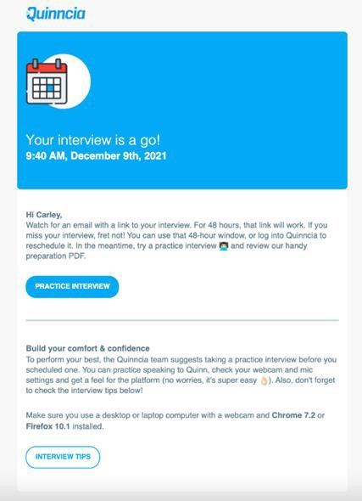

- You will receive an email to connect to your interview about 15 minutes before your scheduled time. Don't be late!
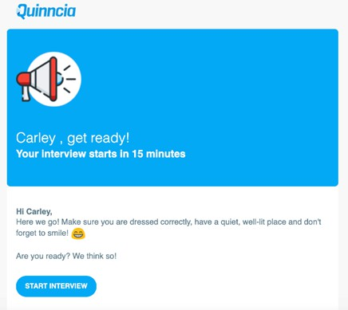
- Follow the link to start your interview. You will have 2 minutes to complete the first questions and 90 seconds for every question after.
- If you still need assistance, refer to this short how-to article: https://help.quinncia.io/article/54-scheduling-an-interview

Understanding Your Quinncia Mock Interview Analysis
After completing your first mock interview, you will receive a page of detailed feedback regarding your performance. You can find individual recordings of your responses and your overall score at the top of the page. Each of the seven questions has a maximum of 100 points, so your total score is calculated out of 700 points (but a perfect score is not the goal; improvement with each mock interview is). Each question breaks down into 25 points for audio, 25 for video, and 50 for content.
Here are the average score ranges for each year:
First Year Students: 200 points or above Second Year Students: 250 points or above Third Year Students: 300 points or above Fourth Year Students: 400 points or above
We also provide a general analysis that highlights all of the metrics Quinn used to calculate your score. Employers use the same method to evaluate interviews, so it is important to consider Quinn's feedback while preparing for interviews.
You will either receive a bronze, silver, or gold badge. There's no need to worry if you don't receive a gold badge, especially as a first- or second-year student!
Badges are based on how you compare to other students at your university. First year students will likely get bronze badges while fourth year students should try to get gold badges. Here is how the badges are awarded:
Gold: Top 10% of scores for your university Silver: Middle 50% of scores for your university Bronze: Bottom 40% of scores for your university
Individual Question Feedback
Audio: Quinn assesses your communication style, rate of speech, filler word usage, answer length, and the skills you discuss most frequently. Her analysis of these individual components sits lower on the page. In the individual question feedback, she synthesizes all of these components and offers suggestions to improve your audio on each question.
A student who scores a gold badge will have less than 2 filler words per minute, rate of speech between 110-130 words per minute. An analytical and confident style of speech, and no background noise.
Video: Quinn analyzes your video by assessing your enthusiasm, micro-expressions, and eye contact. As with audio, Quinn synthesizes all of these components and provides you with video improvements for each question.
To score excellent on video a student would face the screen 85-95% of the time. Their dress would be appropriate to the industry of their choice. Background would be clean and organized. Face would be in good lighting and there would be no glare or lack of lighting.
Content: Quinn also analyzes the information you convey and how you convey it. To conduct this analysis, Quinn uses the technical and essential skills cloud. She identifies the skills you discuss most frequently in your responses and proposes ways to more effectively discuss these skills.

For a student to score a gold badge, they would have clear and concise answers using STAR method, PPF (past-present-future) method, How and Why method or analytical method. They would include technical skills,
essential skills, and quantifiable outcomes. Their stories don’t go on tangents and the answer is relevant to their
industry and job preference.
General Analysis: Overall Interview Data
Rate of Speech: This metric tracks the number of words you say per minute. Quinn analyzes your rate and tells you if it is in the ideal range or not. You should try to speak slowly enough that Quinn can easily understand you, but quickly enough that you are engaging. This metric impacts your overall audio score.
Filler Words: This score represents how many extraneous words you use per minute, such as like, aaa, and um. Quinn also counts any words you extend as filler words. If you drag out the end of a word while thinking of what to say next, Quinn counts it as a filler word. Take a few moments to collect your thoughts before responding to limit the number of filler words you use.
Communication Style: This metric assesses how analytically, confidently, or tentatively you respond. Analytical communication indicates that you express yourself logically and methodically, confidence shows that you believe in yourself and feel sure of your responses, and tentativeness points to hesitancy or unsure answers.
Answer Length: Quinn shows you the ideal response length and where you fall in this range for each question. Staying within this range ensures that you express a solid amount of information without burying the key points under unnecessary detail.
Topic Cloud: The topic cloud extracts the essential and technical skills you’ve mentioned in your responses. The
larger the term, the more frequently you discussed it.
Enthusiasm: This metric measures the excitement you express in each answer by analyzing facial expressions and eye contact. Employers search for eager candidates who will accept their offer and create a positive work environment. While it is important to show your eagerness, you should not aim to have the highest possible level of enthusiasm for each question. You should focus on appearing animated and engaged while responding to the interview questions. When you do that, enthusiasm naturally flows.
Micro-Expressions: This category does not analyze the emotions you are feeling during the interview. Rather, it studies the emotions that your facial expressions convey when you’re telling your story. Let's say you are responding to an interview question about a challenge you overcame in a professional setting. You might use facial expressions which convey fear, surprise, and joy as you tell the story, even though you are not feeling these emotions during the interview. Your micro-expressions score increases as you introduce a wider range of micro-expressions during the interview.
Eye Contact: This metric measures the percentage of time you are looking at your screen or camera to gauge how frequently you make "eye contact." You should typically maintain eye contact for 75-85% of the interview, but no more than 95%.

