




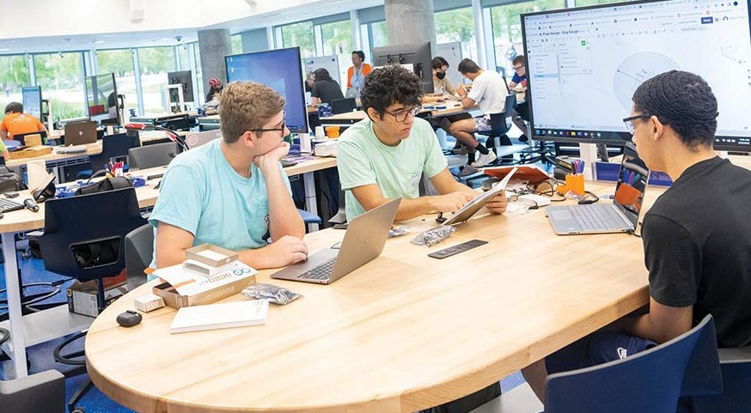


BUILDING AN AI UNIVERSITY
UNIVERSITY OF FLORIDA
AI ACROSS THE CURRICULUM

BECOME AN AI SCHOLAR

ENRICH YOUR STUDIES WITH RESEARCH IN ARTIFICIAL INTELLIGENCE
Undergraduate students who are interested in pursuing AI-related research with a UF faculty member are invited to apply for the AI Scholars Program through the Center for Undergraduate Research. The center manages the successful University Scholars Program that introduces UF undergraduates to partnerships with faculty in research endeavors across campus. Artificial intelligence is ubiquitous in the world around us, from voice-activated devices to autonomous vehicles; thus, there is a wealth of research potential in every UF department.
UNDERGRADUATE AI SCHOLARS
Twenty AI Scholars will be named to join at least 200 other students who are participating in the University Scholars Program who will be undertaking a research project under the guidance of a faculty researcher.
Scholars are selected to participate through a competitive process, which occurs in the spring. Students may apply to the AI Scholar Program without having first identified
a faculty mentor; however, applications with AI faculty support are considered more competitive.

BECOME AN AI SCHOLARS MENTOR
Award Amounts
$1750 for the student
$750 at the beginning of fall, $1000 at the end of spring
Eligibility
- Must not graduate prior to May 2024
- Applications due February 24, 2023
Become an AI Scholars Mentor and invite your qualified undergraduate students to apply to work with you in your lab, studio, or AI research. We have many students looking for opportunities to gain research experience in AI. Mentors receive $500 paid to the department fiscal contact for use in support of student research.

Scan the QR code for mentoring information.

Scan the QR code for scholars’ application instructions and requirements.

The Center for Undergraduate Research in partnership with UF AI2 Center and with support from a UF-FAMU NSF grant is providing this scholars opportunity.

